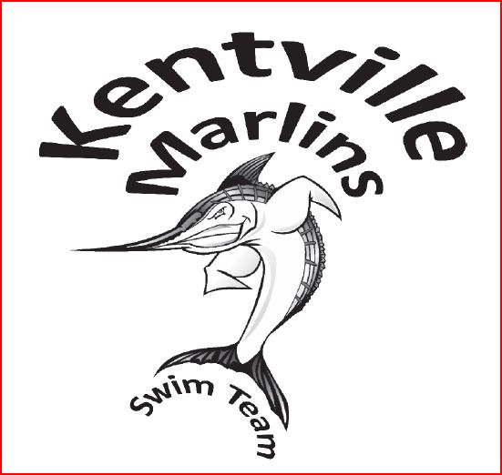
Kentville Marlins Swim Team
192 Murphy Lake Rd., Kentville, Nova Scotia, B4N 3V8
(902) 679-8749
www.Kentvillemarlins.ca
To : Management Team
Re : Kentville Marlins Swim Team, donations request 2016.
Dear Sir/Madame,
The Kentville Marlins Swim Team is a community club that was established with an objective to provide children and the youth access to an affordable and accessible summer swimming program.
The team offers children and the youth ages 5 to 18 from varied economic and social backgrounds, the opportunity to become a member of a vibrant and supportive team. Children and the youth not only have access to swimming related skill development and one-on-one training, as well as opportunity to participate in swimming events which help build individual confidence and promote a healthy and active lifestyle. They also have opportunities to learn team building social networking. Kentville Marlins provide the youth in the community with a positive experience, help them improve in the sport of swimming and provide more competitive swimmers with an avenue to compete provincially.
Kentville Marlins is a registered non-profit organization that is managed by a volunteer executive and parents, with training provided by certified coaches. Kentville Marlins operates on the funds collected through the government grants, sponsorships, donations, membership fees and the revenue generated by fund raising activities. The funds collected are used to pay for the salaries of the coaches, pay for the swim meet expenses, to maintain existing pool equipment and to purchase swim practice equipment as required.
We are approaching your business for a donation of gift cards, merchandise, or certificates for our fundraising events.
Your business's contribution will be featured on our promotional material and mentioned in the swimmers' presentation to potential customers. Our swimmers are energetic sellers and you can rest assured that they will make many people in our community aware of your public-spirited generosity.
Thank you and yours truly,
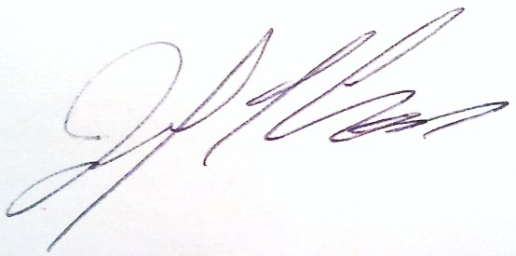
Joe Cross
President, On behalf of Kentville Marlins Swim Team Executive.
Kentville, NS

